**Ideation Phase**

**Define the Problem Statements**

|  |  |
| --- | --- |
| Date | 26 June 2025 |
| Team ID | LTVIP2025TMID36168 |
| Project Name | HealthAI: Intelligent Healthcare Assistant Using IBM Granite |
| Maximum Marks | 2 Marks |

**Customer Problem Statement Template:**

Create a problem statement to understand your customer's point of view. The Customer Problem Statement template helps you focus on what matters to create experiences people will love.

A well-articulated customer problem statement allows you and your team to find the ideal solution for the challenges your customers face. Throughout the process, you’ll also be able to empathize with your customers, which helps you better understand how they perceive your product or service.

Reference: <https://miro.com/templates/customer-problem-statement/>

**Example:**

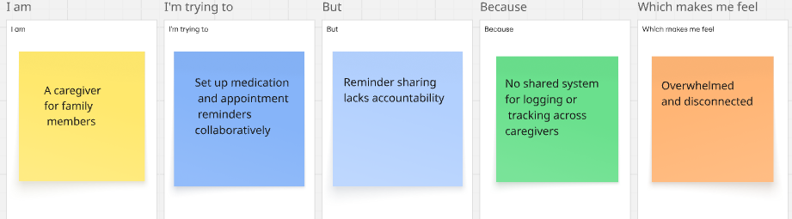

|  |  |  |  |  |
| --- | --- | --- | --- | --- |
| **I am (Customer)** | **I’m trying to** | **But** | **Because** | **Which makes me feel** |
| A busy adult with unpredictable health routines | Log and manage symptoms and wellness routines conveniently | Tracking everything across multiple apps is disjointed | Existing tools don’t integrate symptom analysis with reminders | **Frustrated and neglected** |
| A patient managing chronic conditions | Get quick, personalized advice based on symptom descriptions | AI responses feel generic or unclear | Large language models aren’t fine‑tuned to individual health context | **Anxious and uncertain** |
| A caregiver for family members | Set up medication and appointment reminders collaboratively | Reminder sharing lacks accountability | No shared system for logging or tracking across caregivers | **Overwhelmed and disconnected** |